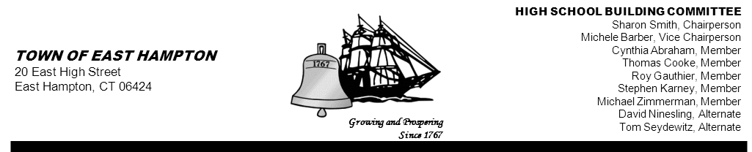

HIGH SCHOOL—ADDITION & RENOVATE-AS-NEW
HIGH SCHOOL BUILDING COMMITTEE MEETING
High School Library/Media Center
15 North Maple Street, East Hampton, CT 06424
Minutes
Thursday, May 2, 2013, 5:30 p.m.
PRESENT AT MEETING
Committee Members: Sharon Smith, Chairperson; Michele Barber, Vice Chairperson; Cynthia Abraham, Stephen Karney, David Ninesling, Tom Seydewitz, Thomas Cooke (arrived 5:45) and Roy Gauthier

Member(s) Absent: Michael Zimmerman, and Keith Klemonski, Parent Liaison

Also Present: Jim Giuliano, CREC Senior Project/Program Manager; Glenn Gollenberg, Principal In Charge SLAM;
Michael MacDonald, NCARB Downs Construction; John Fidler, High School Principal; Mark Winzler, Interim Superintendent

1. Call to Order
The meeting was called to order by Sharon Smith, Chairperson at 5:33 p.m.

2. Public Remarks
None

3. Review and Approve Minutes from April 25, 2013
MOTION: By Roy Gauthier and seconded by Michele Barber,
To approve the 04-25-13 minutes as amended:
Vote (5-0-2) Steve Karney and Tom Seydewitz abstained due to not being present at that time.
Motion unanimously carried

4. Action Items:
- Approval of Invoices

Jim Giuliano reviewed two (2) invoices with the committee:
- invoice from SLAM Collaborative, Inc. for work performed to date as well as worked performed by Fuss & O’Neill, which is included in SLAM’s amendment and previously approved by the Building Committee.
- Invoice from Eagle Environmental, Inc. for their original amount of $5,800.00 for Pre-Renovation/Pre-Demolition Hazardous Building Materials Inspection Services and the amount of $2,364.00 for the Change Order for PLM Overage—Bulk Sample analysis for Asbestos.

MOTION: By Cynthia Abraham, seconded by Michele Barber
to approve the following Invoice:
The SLAM Collaborative, Inc.
Dated: April 11, 2013
Project #12068.00
Invoice #1009150
$64,226.77 Motion unanimously carried

MOTION: By Roy Gauthier, seconded by Stephen Karney
to approve the following Invoice based on CREC’s review and approval:
Eagle Environmental, Inc.
Dated: March 29, 2013
Project #13-019.10
Invoice #10627
$8,164.00 Motion unanimously carried

It was agreed by the committee to attach pre-referendum invoices to the minutes. (copies of invoices attached to bottom of these minutes.)

5. Reports and Discussion:
- Referendum Update
Jim Giuliano reported that there will be a mailer sent out by the town to all households. Mr. Giuliano explained the preparation for the “Explanatory Text” used for the fact sheet, which describes the project for the referendum. Mr. Giuliano stated that the mailer has been put together and that the language is being sent to the Town Attorney and the State Elections and Enforcement Commission (SEEC) for review and approval of content only.

It was agreed that any communication received via emails, should be sent to the whole committee, going forward.

Sharon Smith will follow up with Town Council Chairperson, Sue Weintraub regarding the mailer.

Mr. Winzler stated that he will be reminding parents of the referendum the day before.

A brief discussion took place regarding the informational tri-fold flyer put together by Downes Construction. It was discussed that the PAC may want to use this flyer to help disseminate information. Michele Barber noted that Keith Klemonski, Parent Liaison is attending a PAC meeting tonight.

- Communication Update
Cynthia Abraham reported that she is making arrangements for press releases in the RIVEREST, Middletown Press, and PATCH to advertise for the two (2) informational meetings. One is to be held at the Town Library on May 17, from 1-2:30 p.m. and another immediately following the Town Meeting already scheduled for May 21, at 7 p.m. Ms. Abraham will be contacting Sue Weintraub for additional verbiage pertaining to the Town Meeting. A draft copy was shown to the committee for review , discussion, and approval.

Stephen Karney inquired as to whether progress has been made in getting documents archived. It was discussed that all documents will be going to Michael Maniscalco, Town Manager and possibly be stored at the BOE Building on Main Street. Jim Giuliano commented that he has been keeping copies of invoices, contracts, etc. Michele Barber noted that a tri-board meeting will be held, post- referendum. At that time, communication, data storage, documentation etc. will be discussed to
clarify procedures and protocol.

Jim Giuliano reported that he will meet with Jeff Jylkka and Mike Maniscalco on May 3rd to discuss the “Change Order Process” moving forward.

Stephen Karney inquired as to when the “Quarterly Reports” were due to the Town Council. Tom Seydewitz suggested that since Mr. Giuliano was meeting with Mike Maniscalco this week, it would be a good time to discuss it.

- Schedule Update
Amy Samuelson updated the calendar. Sharon and Michele will forward copies via email to the committee.

Friday, May 17, 2013, 1- 2:30p.m. Public Forum, EH Public Library
Tuesday, May 21, 2013, 7 p.m. Town Meeting, EHHS
Tuesday, May 21, 2013, 7:15 Public Forum, EHHS

Next HSBC Meeting - Thursday, May 16, 2013, 5:30 p.m. EHHS Library
- Sharon Smith will not be in attendance
- Jim Giuliano will not be in attendance but will prepare and forward a proposed Quarterly Report to Michele for the committee’s review.

- Project Management Update
Jim Giuliano reviewed the “Budget Sheet” in detail. A mathematical error was noted and will be corrected on the next copy. The committee also discussed making changes to the format going forward.

Jim Giuliano reported meeting with the Board of Education on Tuesday evening and walked through the science labs, the language lab, and general classrooms. Mr. Giuliano stated that the Ed Specs were discussed and they are moving along. Mr. Giuliano will be meeting with the BOE again next Tuesday evening.

6. Chairperson’s Report
Sharon Smith reported that she heard from Michael Maniscalco who stated that it was a legal opinion that the Building Committee cannot participate in the PAC in any way.

7. Public Remarks
None

8. Adjournment
MOTION: By Michele Barber, seconded by Stephen Karney
to adjourn the meeting at 6:50 p.m.
Motion unanimously carried

Respectfully submitted,

Priscilla Ulm
Recording Secretary

Attachments



